**Chapter 1**

**INTRODUCTION**

**Introduction about IOT**

IoT refers to an Internet Of Things(IoT). Connecting any device (including everything from cell phones, vehicles, home appliances and other wearable embedded with sensors and actuators) with Internet so that these objects can exchange data with each other on a network. It is interesting to note that there is a difference between IoT and the Internet, it is the absence of Human role. The IoT devices can create information about individual’s behaviors, analyze it, and take action. The definition of the Internet of things [3] has evolved due to convergence of multiple technologies, real-time analytics, machine learning, commodity sensors, and embedded systems. Traditional fields of embedded systems [1], wireless sensor networks, control systems, automation (including home and building automation), and others all contribute to enabling the Internet of things.

The wireless communication technologies are rapidly spreading to new areas,including automation, data acquisition, building control, monitoring systems and many more. Autonomous robotic system is an outstanding innovation of a modern technology. It has been able to provide significant support to mankind by accomplishing arduous tasks that are apparently infeasible for human beings to perform. Hence in this project, we focus on a system named as “a human being detector” which will work in disaster environments of manmade structures like borderline, collapsed buildings, war fields etc. It can be assisted for firemen, police, and disaster agencies with appropriate reconnaissance, site evaluation, human detection etc. The proposed method referred nowadays for a human being detector is machine learning using deep learning techniques.

Now a day’s robotics research focused mainly on design and development of autonomous and compliant movable robots for unstructured and natural environments such as planet surfaces rather than for structured industrial environments. These robots can be used to accomplish tasks like rescue, security [4], surveillance in unstructured and natural environments. This class of robots can be utilized for tasks in the hazardous environments where human is not capable of doing it. Emphasizes on the skill of mobility which deals with the motion of mobile robot in an unstructured, unsupervised and real-world environments in order to reach its goals. Here the focus is on locomotion and choice of particular locomotion mechanism which is best when compared to its substitutes. An Internet-based intelligent robot security system, “iBotGuard” in detects trespassers using face recognition algorithm. System can detect a trespasser using intruder detection subsystem which relies on invariant face recognition and it tracks the trespasser using intruder tracking subsystem based on streaming technology. Intruder detection subsystem captures images periodically when it detects trespasser in a secure area and verifies whether the object detected is human using invariant face recognition algorithm then robot will alert the security guards through alert signal using internet. The security guards use the images in robot camera to control robot motion and to recognize trespasser.

**Overview about Machine Learning**

Machine learning is an application of artificial intelligence (AI) that provides systems

The ability to automatically learn and improve from experience without being explicitly programmed. Machine learning focuses on the development of computer programs that can access data and use it learn for themselves. Deep learning techniques provide information about the presence of a human body belongs to the same army group or is a suspect. Reliable specific set of sensors like PIR, IR, Ultrasonic and temperature sensor that gives information about the presence of a human body and a camera to acquire a video of scene of the environment in which the set of sensors trigger the camera to show live scene. The video is then transferred through the cloud to be displayed on pc or laptop which is enhanced by python programming and Deep learning techniques and artificial neural network.

Face detection is a computer technology that determines the locations and sizes of human faces in digital images, which is a key technology in face information processing [2]. It has been widely applied to pattern recognition, identity authentication, human computer interface and automatic video surveillance, etc. At present, the positive face detection has achieved satisfactory results under ideal conditions. However, in the practical situations, this kind of methods cannot be effectively applied to occlusion and multi-pose. Therefore, it is worthwhile to a further investigating for face detection. To handle the face pose variation problem under different conditions, part-based face detection methods have been proposed. Although the proposed part-based face detection methods have attained good results, their performance will decrease in case of occlusion or large pose variation, since those models only summed the scores of part-based detectors without exploring the correlations among the visibilities of different face parts. If a part of the face is occluded or large pose variation, the score of part-based detector would be very low, which would lead to a relatively low summed score. Therefore, the detection rate is insufficient in this state. Currently, Deep Learning is a new area of computer vision and machine learning research, which has been successfully introduced to image dimensional reduction [5, 6] and recognition [7, 8]. Deep learning originates from artificial neural networks and consists of multi-layer perception (MLP) of multi-hidden layers which is a deep learning structure. By using model architectures composed of multiple non-linear transformations, deep learning finds the high-level features in data. The higher level features are derived from lower level features to form a hierarchical representation.

Identifying human faces in digital images has variety of applications, from biometrics and healthcare to video surveillance and security. In psychological terms, face identification is a process through which humans locate and attend to faces in a visual scene. One can consider face detection as a specific case of object class detection. A reliable methodology is based on the Eigen-face technique and the genetic algorithm.

* 1. **Definitions**

1. **Raspberry pi:**The Raspberry Pi is a low cost, **credit-card sized computer** that plugs into a computer monitor or TV, and uses a standard keyboard and mouse. It is a capable little device that enables people of all ages to explore computing, and to learn how to program in languages like Scratch and Python. It’s capable of doing everything you’d expect a desktop computer to do, from browsing the internet and playing high-definition video, to making spreadsheets, word-processing, and playing games. Despite its very small size, don’t underestimate what a Raspberry Pi can do! It is as powerful as a smart phone . The latest version on the market, Raspberry Pi 3, has a **quad-core processor and 1GB RAM**. It can run a real OS on Raspberry Pi, like Raspbian, Ubuntu or Windows IoT, so basically it can do the same things you would have done on your laptop.
2. **IR-Sensors:An infrared sensor is an electronic instrument that is used to sense certain characteristics of its surroundings. It does this by either emitting or detecting infrared radiation. Infrared sensors are also capable of measuring the heat being emitted by an object and detecting motion.**
3. **Face-Recognition:**A facial recognition system is a technology capable of identifying or verifying a person from a digital image or a video frame from a videosource. There are multiple methods in which facial recognition systems work, but in general, they work by comparing selected facial featuresfrom given image with faces within a database**.**
4. **Neural Network:**An Artificial Neural Network (ANN) is an information processing paradigm that is inspired by the way biological nervous systems, such as the brain, process information. The key element of this paradigm is the novel structure of the information processing system. It is composed of a large number of highly interconnected processing elements (neurones) working in unison to solve specific problems. ANNs, like people, learn by example.
5. **MATLAB:MATLAB** (*matrix laboratory*) is a multi-paradigm numerical computingenvironment and proprietary programming languagdeveloped by MathWorks.MATLAallows matrix manipulations, plotting of functions and data, implementation of algorithms, creation of user interfaces, and interfacing with programs written in other languages, including C, C++, C#, Java, Fortran and Python.
   1. **Project Outline**

**Chapter 1: Introduction**

This chapter describes about the domain and the usage of the domain.

**Chapter 2: Review of Literature**

This chapter explains about various reference papers describing about the project.

**Chapter 3: System Requirement Specification**

This chapter describes about the basic requirements for implementing the project.

**Chapter 4: System Design**

This chapter explains about the system architecture, data flow diagram, use case, class, and sequence and activity diagrams.

**Chapter 2**

**REVIEW OF LITERATURE**

* 1. **System Study**

# Implementation of spy robot for a surveillance system using Internet

**protocol of Raspberry Pi [1]**

At present the surveillance of International border areas is a difficult task. The border guarding forces are patrolling the border seriously, but it is not possible to watch the border at each and every moment. An essential requirement of this situation is a robot which automatically detects trespasser in the border and report nearby board security control unit. Many of the military departments now utilize the robots to carry out risky jobs that cannot be done by the soldiers. In this present work, a Raspbian operating system-based spy robot platform with remote monitoring and control algorithm through Internet of Things (IoT)has been developed which will save human live, reduces manual error and protect the country from enemies.

# Human detection using a combination of face, head and shoulder

**Detectors [2]**

Human detection is an active topic with many interesting applications in computer vision. This paper proposes an improved human detection method to extract and segment the human body figure from a given image without prior information. This is done by detecting face, head and shoulder separately, face detection is obtained from Hair classifier while head and shoulder detections are determined from gradient maps, the final human body segmentation is generated based on gap detection and golden ratio. Experiment Results have shown that this method is capable of detecting and segmenting the human body figures robustly from various images.

**2.1.3 Face Recognition and Detection using Neural Networks [3]**

Face recognition is one of the latest technologies being studied area in biometric as it has wide area of applications. But Face detection is one of the challenging problems in Image processing. The basic aim of face detection is determine if there is any face in an image & then locate position of a face in an image. Evidently face detection is the first step towards creating an automated system which may involve other face processing.

**2.2 Proposed Work**

* + 1. **Problem Statement**

The border security suffers from intense human involvement any single technique encounters inextricable problems, such as high false alarm rate. Its very difficult to monitor with many soldiers in border areas because cost it effect so much the military.

**2.2.2 Existing System**

* The existing system uses PIR sensors [1] to detect obstacles which can detect only within 10 meters.
* This system uses AI technique for detection of human [2].
* This system uses laser command as a response for the input given by the commander on recognition of the image.
* L293 motor driver are used for the movement of the robot and obstacle detection [3].
* The existing system sufferedmany problems like high cost to set up communication between robot and rescue controlunit, noisy wireless communication link between robot and control unit which ultimatelystopped robot to function.

**2.2.3 Proposed System**

* The border security system employs high-tech devices, such as IR and Ultrasonic sensors, and camera which is capable of monitoring the border day and night.
* Raising an alarm on detection of human intruders across the borders.
* Send Response image to server so that commander passes specific command to war robot.
* The captured image will be applied ANN to categorize between human and animal.
* Further on classifying the image as human feature classification and face recognition to detect as a solider or suspect.
* Based on commands Robot perform the specific operation
  1. **Scope of the project**
* The proposed system differentiates between animal and human and detects if the human being is a suspect or not in any catastrophic environment.
* Deployment of ground sensors (IR sensors and Ultrasonic Sensors).
* On high signal of IR and Ultrasonic sensor, camera starts recording.
* Raising an alarm on human detection across border using camera and artificial neural network algorithms.
* The system finds out unauthorised people in border areas and send notifications to commanders so that tracking can be possible.

**Chapter 3**

**SYSTEM REQUIREMENTS SPECIFICATION**

* 1. **Functional Requirements**

The functional requirements for a system describe what the system should do. These requirements depend on the type of software being developed, the general approach taken by the organization when writing requirements. The functional system requirements describe the system function in detail, its inputs and outputs, exceptions and so on.

Functional requirements are as follows:

* Border security activities must be performed with minimal effect.
* The application developed must be easily usable.
* The commander must be able to start, switch or stop any activity effortlessly and with minimum time.

.

* 1. **Non-Functional Requirements**

Non functional requirements, as the name suggests, are requirements that are not directly concerned with the specific functions delivered by the system. They may relate to emergent system properties such as reliability, response time and store occupancy. Alternatively, they may define constraints on the system such as capabilities of I/O devices and the data representations used in system interfaces.

The non functional requirements are as follows:

* The total cost of the development must be nominal.
* Performance must be high.
* The size of the robot must be manageable.
  1. **Hardware Requirements**
* Raspberry –Pi
* Pi Camera
* Infrared Sensors
* Gear Motors
* Robot wheels
* Power cables
* Thermal sensors
* Gas sensors
* P1C16F77 diode
* Dot boards
* Power supply
  1. **Software Requirements**
* Python 2.7
* opencv 3.2
* Web application
* Processor: Intel 4 processor with 50GB hard disk.
* Ram:4gb or more
* Windows:8 and above
* Matlab
* Cloud Server

**Chapter 4**

**SYSTEM DESIGN**

**4.1 Design Overview**

The design overview involves in building a robot which consist of raspberry pi kit which controls the entire robot, for each actions of the robot different sensors are used. The Raspberry Pi kit captures the image and will send the image for processing where ANN algorithms shall be used to detect if the human crossing by is a solider or a suspect.

Some operational requirements are:

* The system must run smoothly with no freezing or latching of device.
* The Border Security Robot must immediately perform the specified operation when the instructions are given.

**4.2 System Architecture**

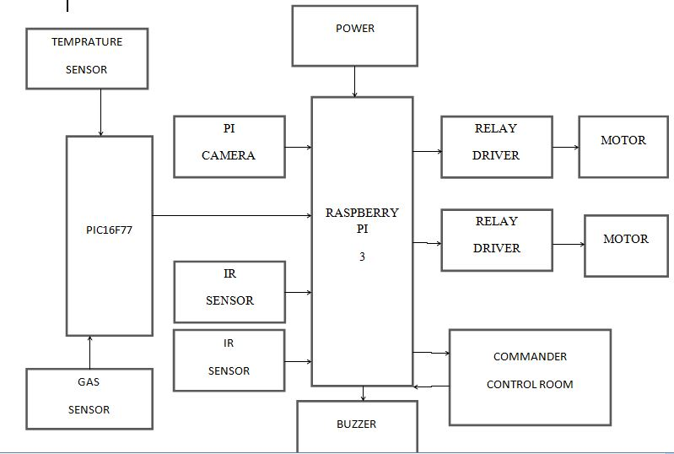

**Figure 4.1 System Architecture of the robot.**

The above figure 4.1 shows the system architecture of the project. The System Architecture contain Raspberry pi kit which act as control processing unit(CPU).PI camera is used to capture a image and the image is sent to the control room through raspberry pi kit. The image is compared with the dataset and if the image is not found in the dataset then the image is sent to the Control Room where the commander monitor’s the image, if it is the suspect the commander sends a command to trigger the buzzer and activate one of the relay driver(GUN). The other relay driver is used for the movement of the robot.IR (infra-red) sensors are used to detect any obstacle in front of the robot. A Gas sensor is used to detect hazardous gases near the border. Thermal sensor is used to detect temperature variations in the robot is it is being attacked. PIC16F77 is used to convert analog output to digital signals, because raspberry pi kit only takes digital signals as inputs. The power supply for the raspberry pi kit is 5V.

**4.3 Data Flow Diagrams**

**4.3.1 Data Flow Diagram - Level 0**

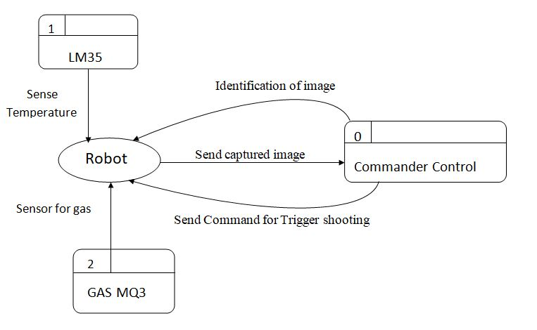

**Figure 4.2DFD-Level 0 of the security system**

The above figure 4.2 shows the data flow diagram level-0 of the project the level 0 data flow diagram shows one process that is the robot which sends the input to the next processor and receives output from the Commander control process. Along with this the robot process sends and receives input from the thermal and the gas sensors.

**4.3.2 Data Flow Diagram - Level 1**

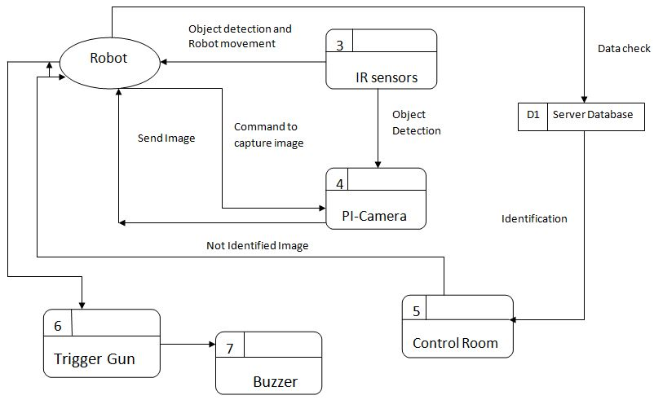

**Figure 4.3DFD-Level 1 of the proposed system**

The above figure 4.3 shows the data flow diagram level-1 of the project. The level 1 data flow diagram shows the complete system where the robot captures the image when the IR sensors detects any obstacle and sends the image to the server database where the identification takes place and if a suspect is identified the trigger command is sent and the buzzer is activated.

**4.3.3 Data Flow Diagram - Level 2**

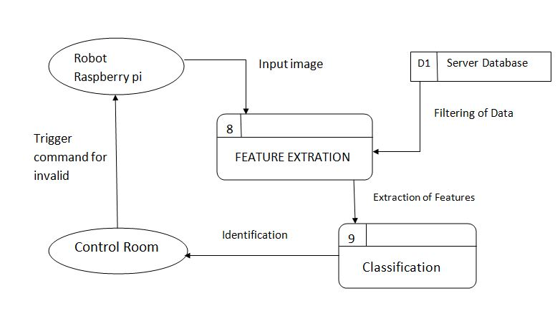

**Figure 4.4DFD-Level 2 for application of neural network.**

The above figure 4.4 shows the data flow diagram level-2 of the projectIn the level 2 of the data flow diagram the further process that takes place at the server is shown where the knowledge present in the server database is considered with the input image, where the features are extracted and identified, on invalid identification trigger command is sent to the robot.

**4.4 Use Case Diagrams­­­­­­**

The use case diagram of the project is a representation of a user’s interaction with the system that shows the relationship with the user and different use cases in which user is involved.

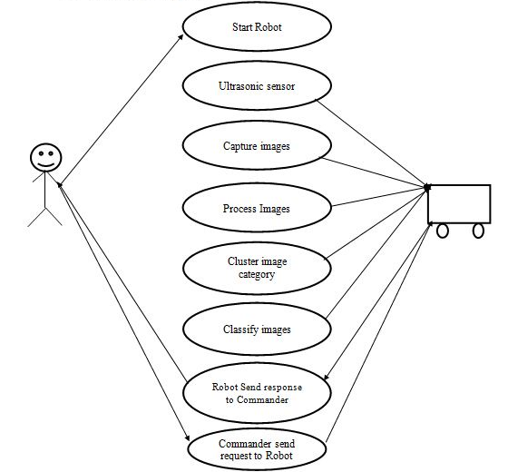

**Figure 4.5 Use case diagram of the system**

The above figure 4.5 shows how the robot in the proposed system works with the other sensors representing the use cases.

**4.5 Class Diagrams**

The class diagram. It is a static diagram that describes the structure of a system by showing the system classes.

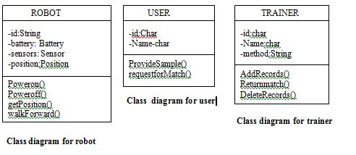

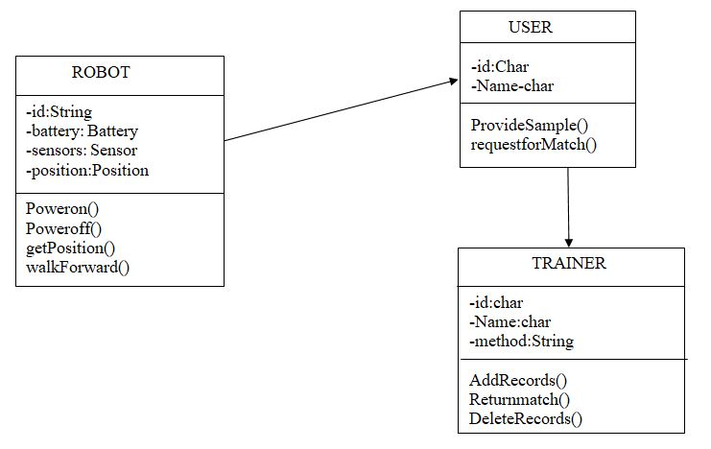

**Figure 4.6 Class diagram for the proposed system**

The above diagram 4.6 shows the different classes and the different attributes for each method, a particular class can have a robot class which can have functions such as sensors, power, etc and the trainer can have matchrecords, returnrecords.

**4.6 Sequence Diagrams**

The sequence diagram shows object interactions arranged in time sequence. It depicts the objects and classes involved in the scenario and the sequence of messages exchanged between the objects.

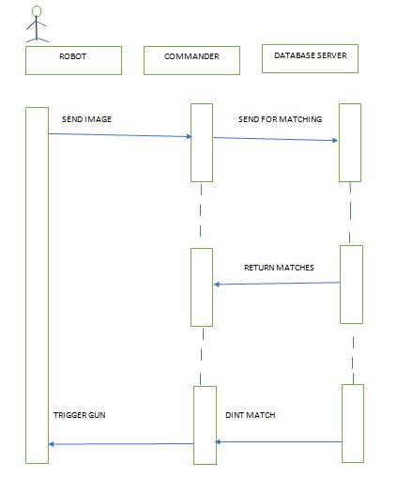

**Figure 4.7 Sequence diagram for the complete system**

The above figure 4.7 shows the sequence diagram where the robot sends the image to the commander for further classification of the image and sending the result back to the robot.

**4.7 Activity Diagrams**

The activity diagrams basically a flowchart to represent the flow from one activity to another activity. The activity can be described as an operation of the system. The control flow is drawn from one operation to another. The flow of the project is described.

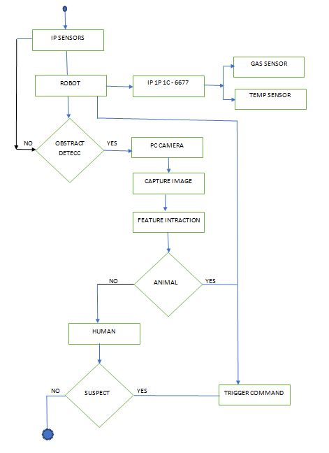

**Figure 4.9 Activity diagram of the proposed system**

The above figure 4.9 shows the activity diagram which describes the flow of how the proposed system works.

**CONCLUSION**

In conclusion of the Phase-1 project the robotic system can detect humans in the borderline areas of a country. Along with this the robot detects hazardous gases and triggers an alarm if the pollution level in the environment is elevated. Firstly, the robot finds the presence of living creatures which is sensed by the IR sensors. The Pi camera segregates the structure of humans and animals, later identifies humans. The human detection is done through prior pre-training which provides highest probability and the obtained result is sent to the command control server. The server contains database of the soldier’s faces. At this server, the face detection and recognition of the soldier works very well with neural networks because even though the face is not proper it can be detected precisely because of hidden layer processing. If the detected face is the solider then the robot does nothing, else the robot activates the relay driver which acts as a gun.

**BIBLIOGRAPHY**

[1] Ghanem Osman ElhajAbdalla, T. Veeramanikandasamy, “Implementation of Spy Robot for A Surveillance System using Internet Protocol of Raspberry Pi”, IEEE, 2017, 86-89, May 2017.

[2] Jürgen Schmidhuber, “Deep learning in neural network: An overview”, Elsevier, Vol. no 61, 2015, 85-117, January 2015.

[3]Priyanka D. Balapure, Darshana N. Wagh, Prof. Bhushan S. Rakhonde“Face Recognition and Detection using Neural Networks”, Volume: 05, 1156-1160 , 2013”.

[4]Anjali Raju , M.Anusha, K.Sunil, K.Swathi and Kashif Ahmed “PatrollingSystem using Unmanned Ground Vehicle for War Field and Border Security, Volume1, 17-20, 2015”.

[5]Rajeev Joshi, Pratap Chandra Poude ,PankajBhandari “An EmbeddedAutonomous Robotic System for Alive Human Body Detection and Rescue OperationVolume 4 ,2014”.

[6]Border Security System,Nitin Srivastava1 Corresponding Author: Neeraj Gupta2,2016.

[7] IOT Based Nautical Monitoring System Kannan.K.R, Hakkem.B, Vignavi.K, Vinoth.P, Mohammed NoorulKarim.M, Rajbabu.V, Volume VII, Issue III, March 2018.

[8] Face Recognition and Detection using Neural Networks, Vinita Bhandiwad,Department of Information technology, Vidyalankar Institute of technology, Mumbai BhanuTekwani, ICEI 2017.